Pre-Hydration via Rapidojet of 100% of Flour to final mixer

Procedure:

- In the following examples, just by pre-hydrating flour to the final mixer via Rapidojet, the hydration level was increased from 75% to 85%. Dough felt the same and machinability was not harmed.
- The process resulted in significantly reduced cost due to additional water (yield)
- Production capacity was doubled because mixing time was cut by more than half. Mixing time had been 4 in low and 10 in high. Low speed was totally eliminated. Only 5 minutes in high speed.
- The last 3 pictures show a rye-wheat-bread.
- Freshness was significantly better after 3 days vs. Control.
- The process resulted in increased quality: volume and shelf-life (softness)
- For the buns ("Schnittbrötchen"), the baker increased total hydration level from 51% to 60 %.

Comments from a German baker:

„anbei die Fotos der getesteten Produkte…..HAMMER !!!
Top Qualitäten !!!“ Translation: Here are the pictures of the product from yesterday.....Excellent!!
Top Quality!!!“
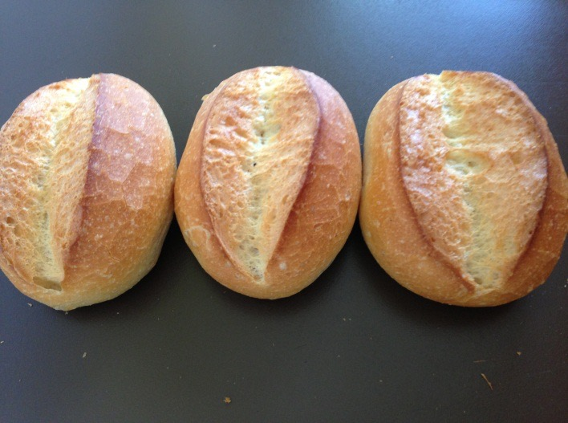

Proud Member of
Bakery Concepts International, LLC. - P.O. Box 234, Enola, PA 17025 - Phone (610) 574-9565 - Fax (717) 732-8169

Rapidojet
control
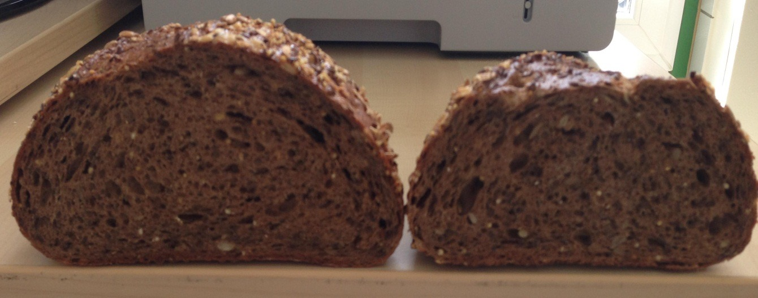

Rapidojet
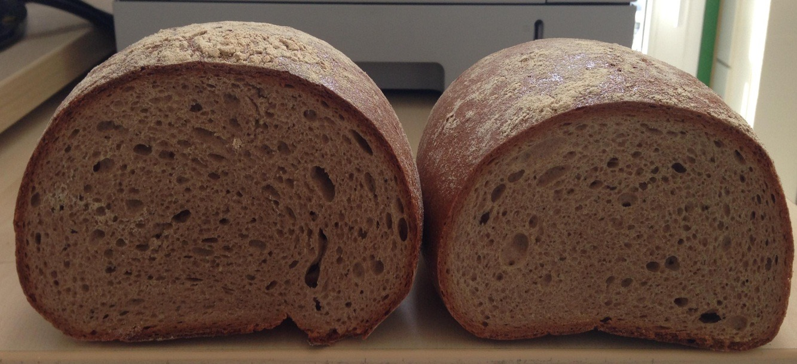
control

Proud Member of
Bakery Concepts International, LLC. - P.O. Box 234, Enola, PA 17025 - Phone (610) 574-9565 - Fax (717) 732-8169

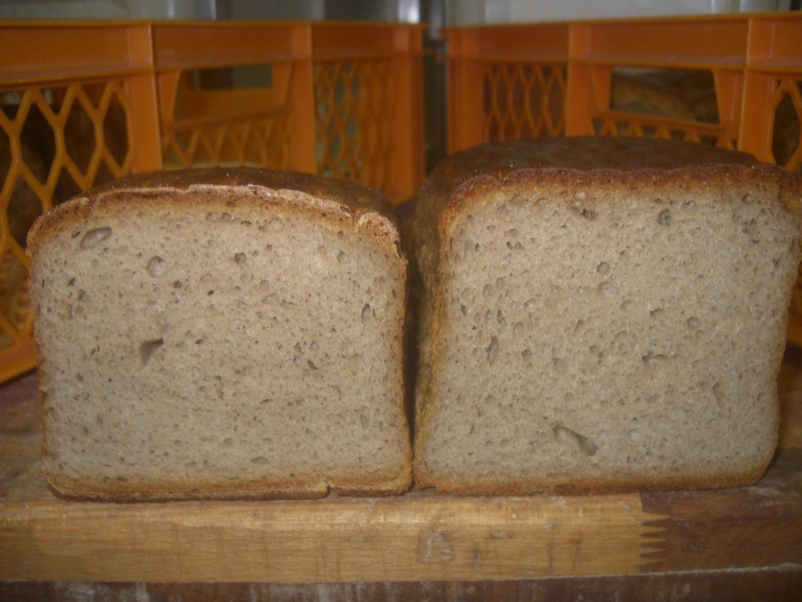
Rapidojet
control
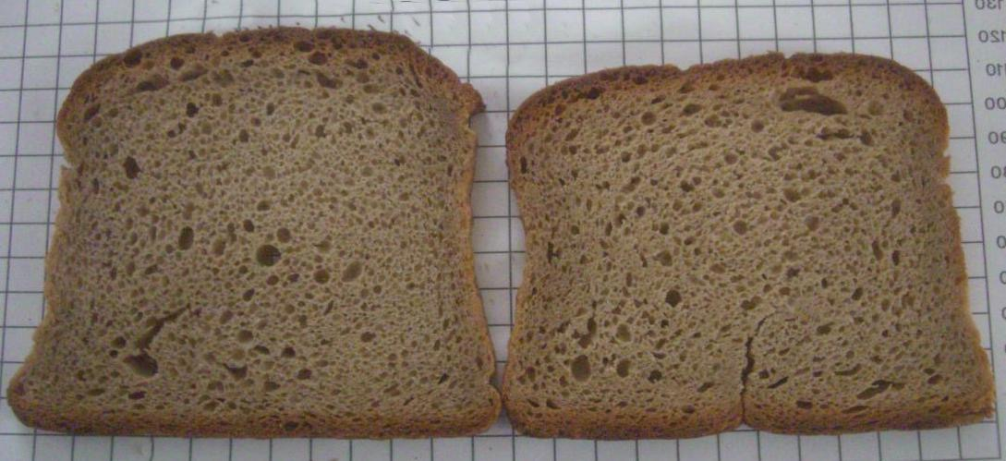
control
Rapidojet

Proud Member of
Bakery Concepts International, LLC. - P.O. Box 234, Enola, PA 17025 - Phone (610) 574-9565 - Fax (717) 732-8169

